Name: ____________________________ Period: _____
Unit 7.3: Inverse Relations and functions
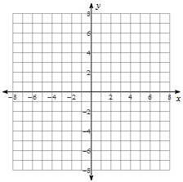
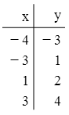
Find the inverse of each relation shown below. Graph the given relation and it’s inverse.
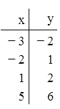
1. 2.

Find the inverse. Decide if the inverse is a function and state how you know.
3. $y=2x-3$ 4. $y=$ $\frac{x+9}{2}$

5. $f\left(x\right)=\frac{1}{2}x-2$ 6. $f\left(x\right)=\sqrt{2x-1}$

7. $y=4x^{2}-4$ 8. $f\left(x\right)=2x^{2}+5$

11. $f\left(x\right)=$ $\frac{7x-6}{x-1}$ 12. $y=$ $\frac{2x^{2}}{5}$ +1

Graph each relation and it’s inverse.
13. $y=5-2x$ 14. $f\left(x\right)=\sqrt[3]{x-1}$
9. $y={\left(x+2\right)}^{2}$ 10. $f\left(x\right)={(2-2x)}^{2}+1$

For each function below: (a) find the inverse of each function, (b) find the domain and range of the function and it’s inverse, (c) determine if the inverse is a function.
15. $f\left(x\right)=\sqrt{x-4}$ 16. $f\left(x\right)={(x-2)}^{2}$

Determine if $g(x)$ is an inverse function of $f(x)$.
17. $f\left(x\right)=3x-1$ 18. $f\left(x\right)=x^{3}-1$
$g\left(x\right)=$ $\frac{x-1}{3}$ $g\left(x\right)=\sqrt[3]{x+1}$

